Accessing High-Quality Images on Artstor via Jstor
- Go to Jstor.org and click the “Log in” button
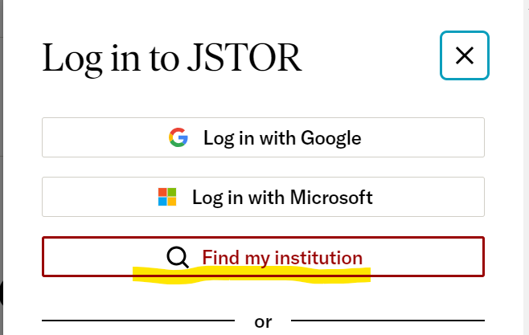

- Select “Find my institution”

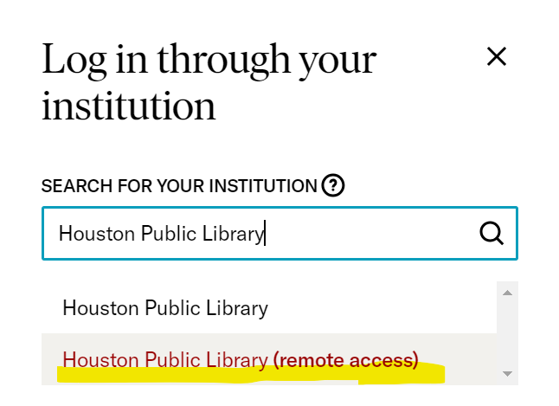
- Start typing “Houston Public Library” and select “Houston Public Library (remote access)” from the dropdown menu:

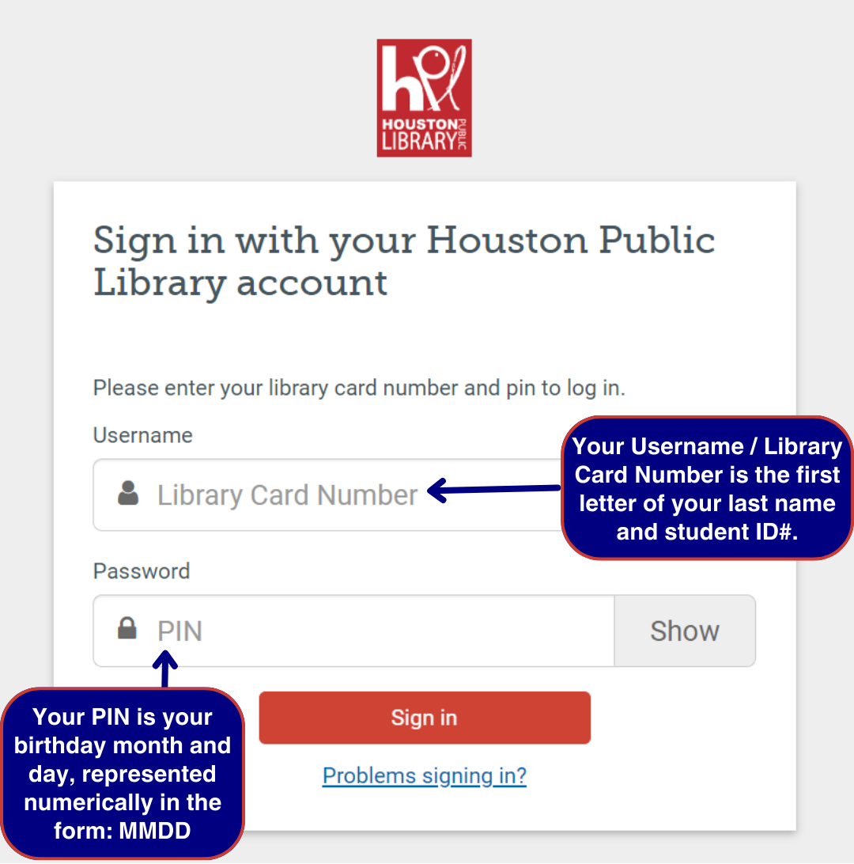
- Enter your “Library Card Number” and “PIN”
Library Card Number is the first letter of your last name and student ID,
ex. A1234567

PIN is the month and day of your birthday, represented numerically in the format MMDD,
ex. 0115 for Jan. 15th

- Once you’re logged in, search your artist and artworks to find high-quality images on Artstor. When you find an image you may want to use, click on it.
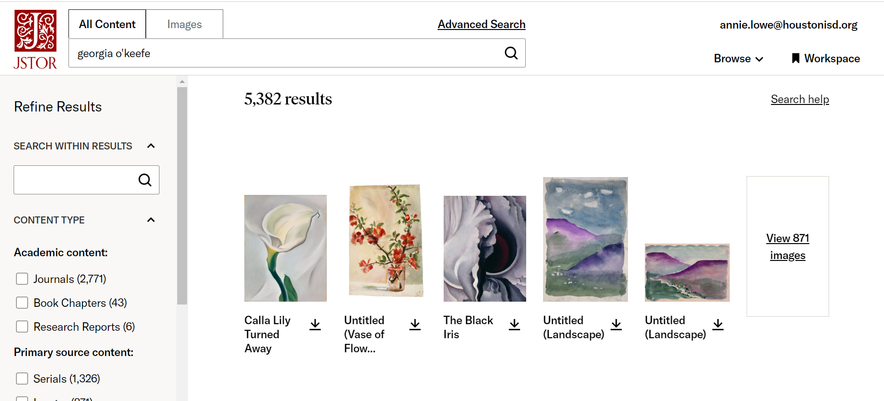

- Download the image and save it in your IB Visual Arts research folder. (Make the folder in your Google Drive unless instructed otherwise.)
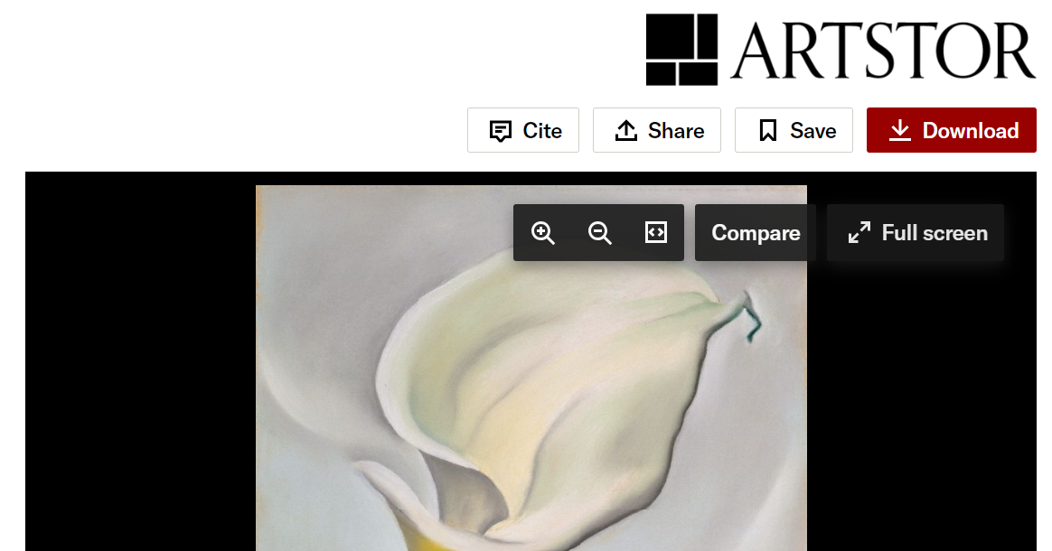
Click the “Cite” button and copy the MLA citation. Add a Works Cited or Reference List document to your folder if you haven’t already, and paste the image citation in the document. Alternatively, you could make a document for images, insert your artwork image, and paste the image citation alongside.

